HARDWARE AND COMPONENTS BASICS

ASSIGNMENT DAY1
TASK1. Draw a labeled diagram of a desktop PC, clearly marking the motherboard, CPU, RAM, GPU, and both HDD and SSD storage components.
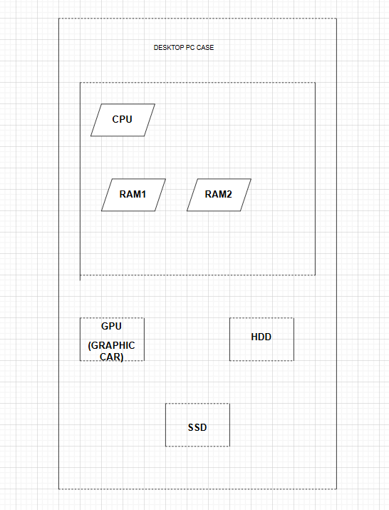
- Motherboard – Main circuit board connecting all components.
- CPU – Central Processing Unit.
- RAM – Temporary memory used by programs.
- GPU – Graphics Processing Unit.
- HDD – Hard Disk Drive for storage.
- SSD – Solid State Drive for fast storage.

TASK2. Create a comparison table showing the main differences between HDD and SSD storage in terms of speed, durability, and typical use cases.<br><br><em><strong>Hint:</strong> Think about which one is faster, which is more shock-resistant, and where you would usually find each type (laptop, gaming PC, etc.).</em>
Feature | HDD (Hard Disk Drive) | SSD (Solid State Drive)
Storage Technology | Magnetic spinning disks | Flash memory chips
Speed | Slower | Much faster
Boot Time | 30–60 seconds | 10–20 seconds
Durability | Less durable due to moving parts | More durable, no moving parts
Noise | Produces noise while operating | Silent operation
Power Consumption | Higher | Lower
Shock Resistance | Low | High
Cost per GB | Cheaper | More expensive
Typical Use | Large storage, backups | Operating system, gaming, applications
Commonly Found In | Budget PCs, storage servers | Modern laptops, gaming PCs

TASK3. Write a short explanation (2-3 sentences each) describing the role of the CPU, RAM, and GPU in running a game like PUBG or Free Fire on a PC.
- CPU (Central Processing Unit)
The CPU acts as the brain of the computer. In games like PUBG or Free Fire, it processes player actions, game logic, AI behavior, and communication between different hardware components. A faster CPU helps maintain smooth gameplay and stable frame rates.
- RAM (Random Access Memory)
RAM temporarily stores game data that is actively being used. When playing PUBG or Free Fire, maps, textures, and game information are loaded into RAM for quick access. More RAM helps reduce loading times and prevents lag during gameplay.
- GPU (Graphics Processing Unit)
The GPU is responsible for rendering graphics, textures, lighting, and visual effects. In games such as PUBG or Free Fire, the GPU generates the images displayed on the screen. A powerful GPU provides higher frame rates and better graphics quality.

TASK4. Imagine you want to upgrade your PC to run the latest version of FIFA smoothly. List which hardware components you would consider upgrading and explain why for each.

1. Graphics Card (GPU)
Why Upgrade?
- FIFA uses advanced graphics and visual effects.
- A better GPU improves frame rates and image quality.
Example Upgrade:
- NVIDIA RTX 4060
- AMD RX 7600

2. RAM
Why Upgrade?
- More RAM allows the game to load assets quickly.
- Prevents lag when multitasking.
Recommended:
- Upgrade from 8 GB to 16 GB RAM.
3. Storage Drive
Why Upgrade?
- Installing FIFA on an SSD significantly reduces loading times.
- Faster game launches and updates.
Recommended:
- 500 GB or 1 TB SSD.
4. Processor (CPU)
Why Upgrade?
- A stronger CPU handles game physics, AI, and background tasks efficiently.
- Improves overall gaming performance.
Recommended:
- Intel Core i5/i7 (latest generation)
- AMD Ryzen 5/Ryzen 7
5. Power Supply (SMPS)
Why Upgrade?
- New GPUs and CPUs require more power.
- Ensures stable operation of all upgraded components.
Recommended:
- 550W–750W quality power supply.

